Module 3: Android User Interface Design Essentials
1-Exploring User Interface Screen Elements
User Interfaces (UI) in Android can be built within two ways, by defining XML-Code or by writing Java-Code. Defining the GUI structure in XML is highly preferable, because as one knows from the Model-Viewer-Control principle that the UI should always be separated from the program-logic. Additionally adapting a program from one screen-resolution to another is a lot easier.

Defining a UI in XML is very similar to creating a common HTML-document, where you have i.e. such a simple file:

<html>
<head>
<title>Page Title</title> </head>
<body>
The content of the body element.
</body>
</html>

Just the same as in Android’s XML-Layouts. Everything is well structured and can be expressed by tree-structures:

<?xml version="1.0" encoding="utf-8"?> <LinearLayout
xmlns:android="http://schemas.android.com/apk/res/android" android:orientation="vertical" android:layout_width="fill_parent" android:layout_height="fill_parent"> <TextView android:layout_width="wrap_content" android:layout_height="wrap_content" android:text="Hello World"/> </LinearLayout>

Hierarchy of Screen Elements
The basic functional unit of an Android application is the activity-an object of the class android.app.Activity. An activity can do many things, but by itself it does not have a presence on the screen. To give your activity a screen presence and design its UI, you work with views and viewgroups - basic units of user interface expression on the Android platform.

Views
A view is an object extending the base class android.view.View. It's a data structure whose properties store the layout and content for a specific rectangular area of the screen. A View object handles measuring, its layout, drawing, focus changes, scrolling, and key/gestures for the screen area it represents.
The View class serves as a base class for all widgets - a set of fully implemented subclasses that draw interactive screen elements. Widgets handle their own measuring and drawing, so you can use them to build your UI more quickly. The list of widgets available includes i.e. TextView, EditText, Button, RadioButton, Checkbox, ScrollView, …
Viewgroups
A viewgroup is an object of class android.view.Viewgroup. As its name indicates, a viewgroup is a special type of view object whose function is to contain and manage a subordinate set of views and other viewgroups, Viewgroups let you add structure to your UI and build up complex screen elements that can be addressed as a single entity.
The Viewgroup class serves as a base class for layouts - a set of fully implemented subclasses that provide common types of screen layout. The layouts give you a way to build a structure for a set of views.
A Tree-Structured UI
On the Android platform, you define an Activity's UI using a tree of view and viewgroup nodes, as shown in the diagram below. The tree can be as simple or complex as you need to make it, and you can build it up using Android's set of predefined widgets and layouts or custom view types that you create yourself.

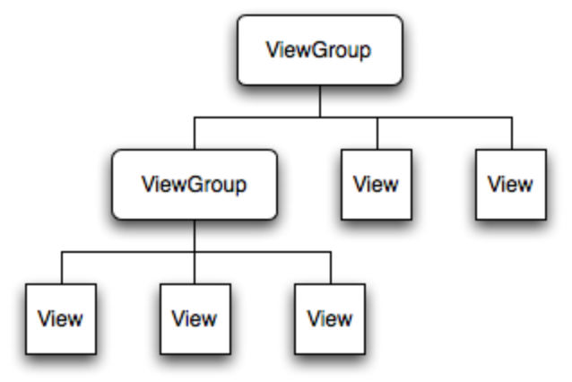

Picture 4 Android UI - Tree structure
To attach the tree to the screen for rendering, your Activity calls its setContentView() method and passes a reference to the root node object. Once the Android system has the reference to the root node object, it can work directly with the node to invalidate, measure, and draw the tree. When your Activity becomes active and receives focus, the system notifies your activity and requests the root node to measure and draw the tree. The root node then requests that its child nodes draw themselves - in turn, each viewgroup node in the tree is responsible for drawing its direct children. As mentioned previously, each view group has the responsibility of measuring its available space, laying out its children, and calling draw() on each child to let it render itself. The children may request a size and location in the parent, but the parent object has the final decision on where how big each child can be.
Comparing Android UI Elements to Swing UI Elements
As some developers who are reading this have probably coded UIs with Swing before here are some similarities between Android and Swing.

• Activities in Android refers almost to a (J)Frame in Swing.

• Views in Android refers to (J)Components in Swing.

• TextViews in Android refers to a (J)Labels in Swing.

• EditTexts in Android refers to a (J)TextFields in Swing.

• Buttons in Android refers to a (J)Buttons in Swing.

Setting listeners to a View is nearly the same in Android than in Swing
in Android-
myView.setOnClickListener(newOnClickListener(){

In Swing- myButton.addActionListener(new ActionListener() {...

2-Designing User Interfaces with Layouts
Layouts
Layouts are Android’s solution to the variety of screens that come on Android devices: they can have different pixel densities, different dimensions, and different aspect ratios. Typical Android devices, such as the HTC G1 mobile phone, even allow changing the screen orientation (portrait or landscape) while applications are running, so the layout infrastructure needs to be able to respond on the fly. Layouts are intended to give developers a way to express the physical relationship of Views as they are drawn on the screen. As Android inflates the Layout, it uses the developer requests to come up with a screen layout that best approximates what the developer has asked for.

Looking a little deeper, layouts in Android are in the form of a tree, with a single root and a hierarchy of Views. Look back at any of the XML Layout files in the previous section and you’ll see that the XML tags create just such a hierarchy, with a screen Layout as the root of the tree. Each View in the tree is termed the parent of the Views it contains and the child of the View that contains it. Layout is a two-pass process:

Measure pass
Traversing the tree from the root, each View in the layout records its dimensional request—in other words, how much vertical height and horizontal width it needs to display itself in the final display.

Layout pass
Again traversing the tree from the root, each parent View uses the available layout information to position its children as requested. If the requests can’t be followed explicitly, Android does its best to make everything fit on the screen. If there are no requests given, it uses a default set of layout parameters. Each parent can pass
layout information on to its children, telling them where they are positioned and what screen dimensions they have been granted (they might get less than they requested). A Layout is a View itself, so there’s nothing wrong with having multiple Layouts in a
single layout XML file—they just have to be arranged in a hierarchy. So it’s perfectly valid to have a vertical LinearLayout that includes a TableLayout as one of its rows.

Frame Layout
The Frame Layout is sort of a null layout specification. It reserves space on the screen for a single View to be drawn, and the View is always located at the upper left of the space. There is no way to specify a different location for the View, and there can be only one View in the Layout. If more than one View is defined in the layout file, they are just drawn on top of each other, all pinned to the upper-left corner.

LinearLayout
LinearLayouts are used extensively in Android applications, and we used them in example code earlier. A LinearLayout asks that the contained Views be layed out as either a series of rows (vertical LinearLayout) or a series of columns (horizontal
LinearLayout). In a vertical LinearLayout, all the rows are the same width (the width of the widest child). In a horizontal LinearLayout, there is one row of Views, all the same height (the height of the tallest child).

In Figure -1 shows an example of a vertical LinearLayout, and Figure -2 is an example of a horizontal one. Both have EditText Views as children. Example 11-9 shows the XML resource file that produces the vertical layout, and Example 11-10 shows the
file that created the horizontal one.

Vertical LinearLayout resource file

<?xml version="1.0" encoding="utf-8"?>
<LinearLayout xmlns:android="http://schemas.android.com/apk/res/android"
android:orientation="vertical"
android:layout_width="fill_parent"
android:layout_height="fill_parent"
>
<EditText
android:layout_width="fill_parent"
android:layout_height="wrap_content"
android:text="EditText1"
/>
<EditText
android:layout_width="fill_parent"
android:layout_height="wrap_content"
android:text="EditText2"
/>
<EditText
android:layout_width="fill_parent"
android:layout_height="wrap_content"
android:text="EditText3"
/>
<EditText
android:layout_width="fill_parent"
android:layout_height="wrap_content"
android:text="EditText4"
/>
</LinearLayout>

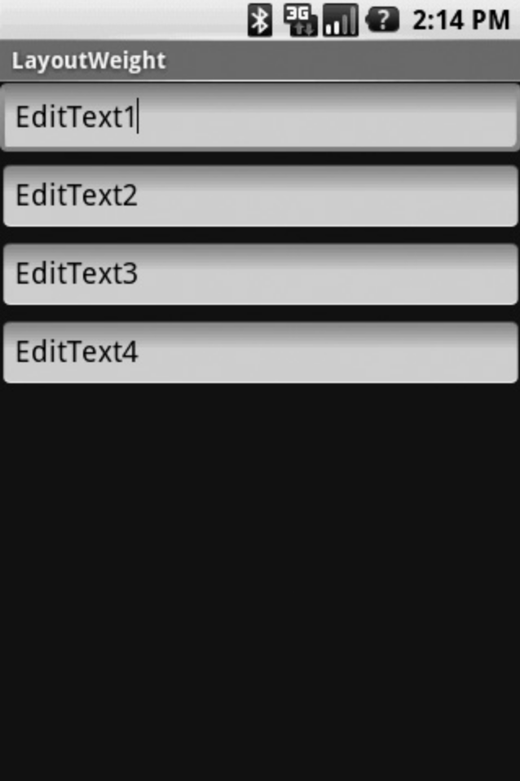

<?xml version="1.0" encoding="utf-8"?>
<LinearLayout xmlns:android=http://schemas.android.com/apk/res/android
android:layout_width="fill_parent"
android:layout_height="fill_parent"
>
<EditText
android:layout_width="wrap_content"
android:layout_height="fill_parent"
android:text="E1"
/>
<EditText
android:layout_width="wrap_content"
android:layout_height="fill_parent"
android:text="E2"
/>
<EditText
android:layout_width="wrap_content"
android:layout_height="fill_parent"
android:text="E3"
/>
<EditText
android:layout_width="wrap_content"
android:layout_height="fill_parent"
android:text="E4"
/>
</LinearLayout>

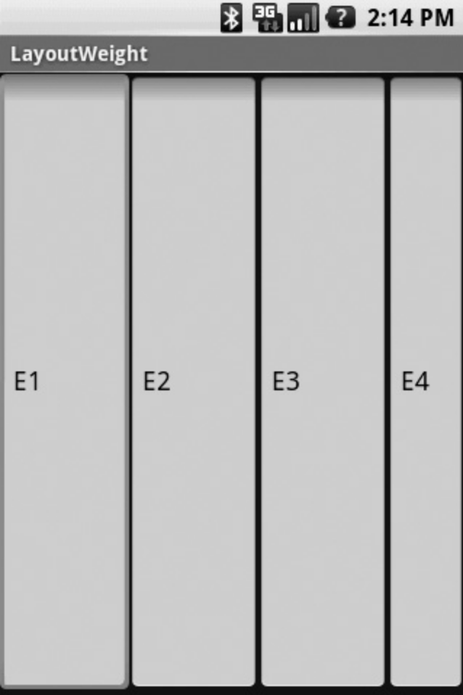

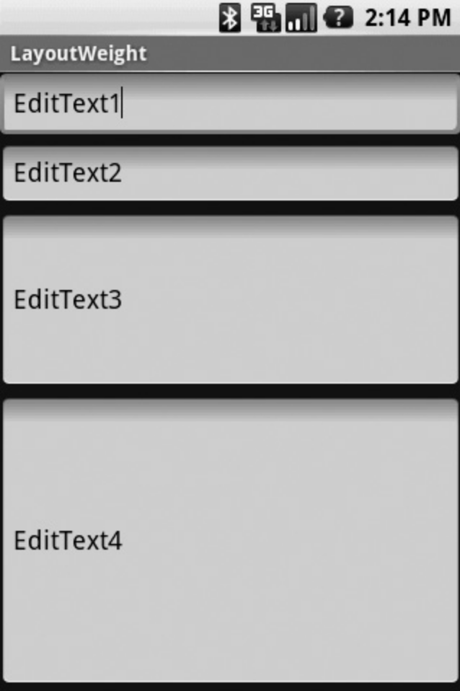

The horizontal layout might not look exactly as you would think: how come E4 is narrower than the other three? The answer is that there is a default minimum width for an EditText. If you build and run the horizontal example and type something into
EditText E1, you’ll see that it expands in width as the line gets longer, which is just what we asked for with android:layout_width="wrap_content".

In addition to the usual dimensional parameters for child Views (width, height, padding), you can include a weight for each child (attribute android:layout_weight=;weight). The weight tells the layout manager how you want to use unfilled space, and defaults to a value of 0. If you specify children with weights greater than zero, the layout manager will allocate unused space to each child in proportion to its weight.

Figure -3 shows an example of a LinearLayout containing four EditTexts. The first two have no weights assigned. EditText3 has a weight of 1 and EditText4 has a weight of 2. The effect is to make EditText4 twice as big as EditText3, while EditText1 and
EditText2 just split whatever space the layout leaves over.
TableLayout
A TableLayout is just what you’d expect: it lays out the included Views in the form of a table (similar to an HTML table). We can create a table of TextViews to show how you would create that kind of screen for an application. Here’s an example TableLayout
XML file:

<?xml version="1.0" encoding="utf-8"?>
<TableLayout xmlns:android="http://schemas.android.com/apk/res/android"
android:id="@+id/tblJobs"
android:layout_width="fill_parent"
android:layout_height="wrap_content"
>
<TableRow
android:layout_width="fill_parent"
android:layout_height="wrap_content">
<Button android:text="Cell 11"
android:id="@+id/btnCel11"
android:layout_width="20dip"
android:layout_height="wrap_content"
/>
<TextView
android:id="@+id/txtCell12"
android:layout_width="20dip"
android:layout_height="wrap_content"
android:text="Cell 12"
/>
<TextView
android:id="@+id/txtCell13"
android:layout_width="20dip"
android:layout_height="wrap_content"
android:text="Cell 13"
/>
<TextView
android:id="@+id/txtCell14"
android:layout_width="20dip"
android:layout_height="wrap_content"
android:text="Cell 14"
/>
</TableRow>
<TableRow
android:layout_width="fill_parent"
android:layout_height="wrap_content">
<Button android:text="Cell 21"
android:id="@+id/btnCo21"
android:layout_width="80dip"
android:layout_height="wrap_content"
/>
<TextView
android:id="@+id/txtCell22"
android:layout_width="80dip"
android:layout_height="wrap_content"
android:text="Cell 22"
/>
<TextView
android:id="@+id/txtCell23"
android:layout_width="80dip"
android:layout_height="wrap_content"
android:text="Cell 23"
/>
<TextView
android:id="@+id/txtCell24"
android:layout_width="80dip"
android:layout_height="wrap_content"
android:text="Cell 24"
/>
</TableRow>
</TableLayout>
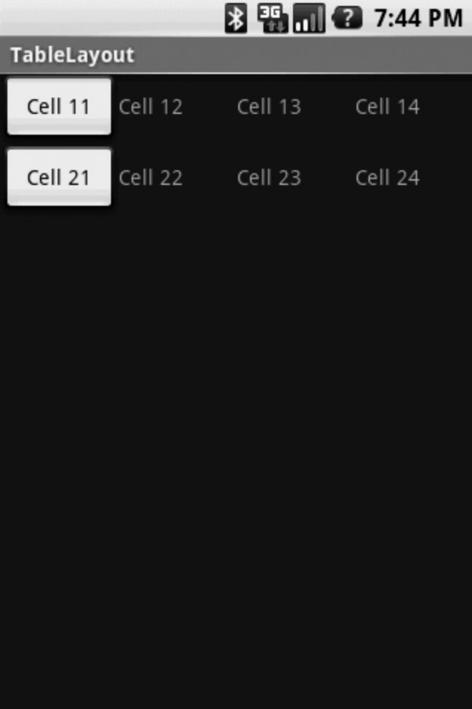

The structure of the XML file is pretty evident: the TableLayout tags contain a list of TableRows that in turn contain the Views you want to appear on each line of the table. Notice that the layout_width values are different in the two rows—all the widths in the first row are specified as 20dip, whereas the widths in the second row are specified as 28dip—yet the columns line up on the screen. To preserve the look of a table, Android makes each column as wide as the widest cell in that column.
Of course, the cells are addressable from your Java code, and you can add rows programmatically to the table, if that’s what your application needs to do.

AbsoluteLayout
An AbsoluteLayout puts views on the screen wherever you tell it to. It doesn’t try to resize anything, and it doesn’t try to line anything up; it just puts things where it’s told. You might think that it would be an easy type of layout to use, since you don’t have to
second-guess how the layout manager is going to rearrange things on your screen, but in practice the use of AbsoluteLayout is a bad idea for almost all applications. You usually want your application to run on as many Android devices as possible, and the strength of the Android layout manager is that it will automatically adapt your screen layout from device to device. AbsoluteLayout bypasses most of the layout manager, and while your application may look perfect on the device you used for development, the odds are very good that it will look terrible on other Android devices.That warning aside, let’s take a look at an AbsoluteLayout XML file:

<?xml version="1.0" encoding="utf-8"?>
<AbsoluteLayout xmlns:android="http://schemas.android.com/apk/res/android"
android:orientation="vertical"
android:layout_width="fill_parent"
android:layout_height="fill_parent"
>
<TextView
android:layout_width="fill_parent"
android:layout_height="wrap_content"
android:text="Upper Left"
android:layout_x="0.0px"
android:layout_y="0.0px"
/>
<TextView
android:layout_width="fill_parent"
android:layout_height="wrap_content"
android:text="Middle"
android:layout_x="140.0px"
android:layout_y="200.0px"
/>
<TextView
android:layout_width="fill_parent"
android:layout_height="wrap_content"
android:text="Lower Right"
android:layout_x="240.0px"
android:layout_y="400.0px"
/>
</AbsoluteLayout>

As with any dimension in a layout file, the positions can be expressed in pixels (px),device-independent pixels (dp), scaled pixels (sp), inches (in), or millimeters (mm), and

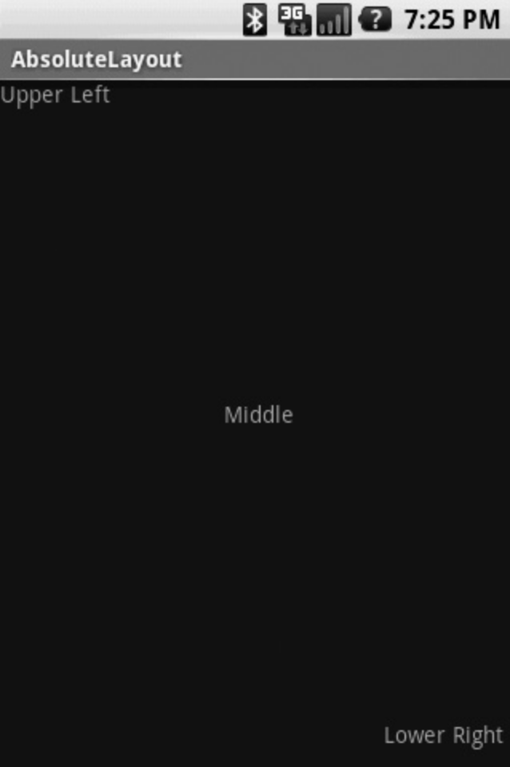
the dimension has to be a floating-point number. (For more about expressing sizes, see

Figure -5 shows the resulting screen layout. Obviously, the position (0, 0) is the upper-left corner of the display, and the View is properly flush with the corner. The lower-right corner on the emulator is supposed to be (320, 480), but the View appears
to be a little shy of that in both dimensions.

Just to caution against the use of AbsoluteLayout again, we suggest you try changing the emulator skin to show the screen in landscape mode (enter emulator -skin HVGA-L from a command or terminal window before you run the application), and you can see in Figure 11-16 that the application no longer looks right.

RelativeLayout
We’ve used RelativeLayout, often in combination with LinearLayout, throughout the MJAndroid application. The advantage of RelativeLayout is that you can express
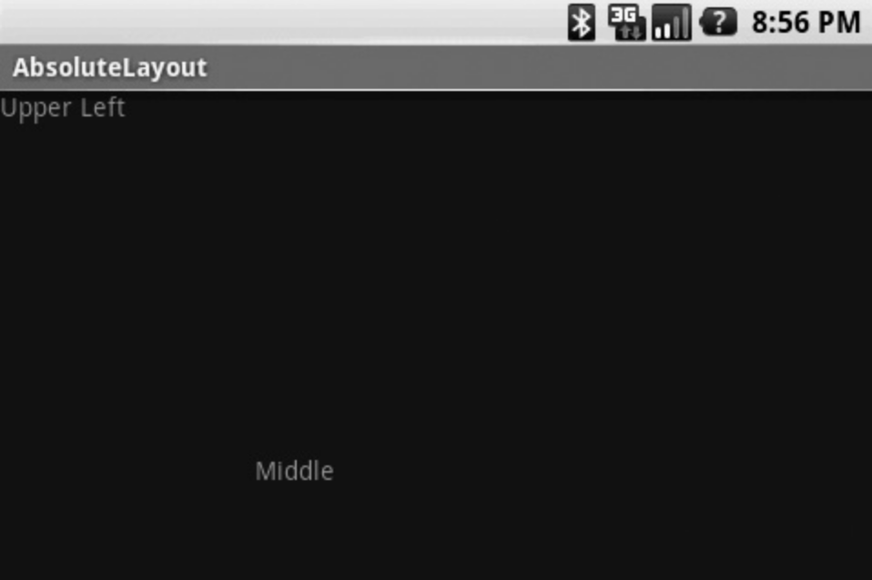
relative positioning of the Views in the screen, and the layout manager will do its best to fit them all on the screen in the proper relations. An example follows:

<?xml version="1.0" encoding="utf-8"?>
<RelativeLayout xmlns:android="http://schemas.android.com/apk/res/android"
android:orientation="vertical"
android:layout_width="fill_parent"
android:layout_height="fill_parent"
>
<TextView
android:id="@+id/txtText1"
android:layout_width="wrap_content"
android:layout_height="wrap_content"
android:text="Text1"
android:gravity="top"
android:layout_alignParentRight="true"
/>
<TextView
android:id="@+id/txtText2"
android:layout_width="wrap_content"
android:layout_height="wrap_content"
android:text="Text2"
android:layout_below="@+id/txtText1"
/>
<Button
android:id="@+id/btnButton1"
android:layout_width="150dp"
android:layout_height="wrap_content"
android:text="Button1"
android:layout_below="@+id/txtText2"
/>
<Button
android:id="@+id/btnButton2"
android:layout_width="150dp"
android:layout_height="100dp"
android:text="Button2"
android:layout_toRightOf="@+id/btnButton1"
android:layout_alignTop="@+id/btnButton1"
/>
</RelativeLayout>

1-Lays out Text1 at the top of the screen.

2- Aligns Text1 with the right side of its parent (which is the screen itself).
3- Places Text2 below Text1.
4- Places Button1 below Text2.
5- Places Button2 just to the right of Button1.
6- Aligns the tops of the two buttons.

Figure -7 shows what this looks like in portrait mode (the emulator default), and Figure- 8 shows it in landscape mode. The layout manager has adjusted the arrangements in each case to match the layout hints we gave in the XML.
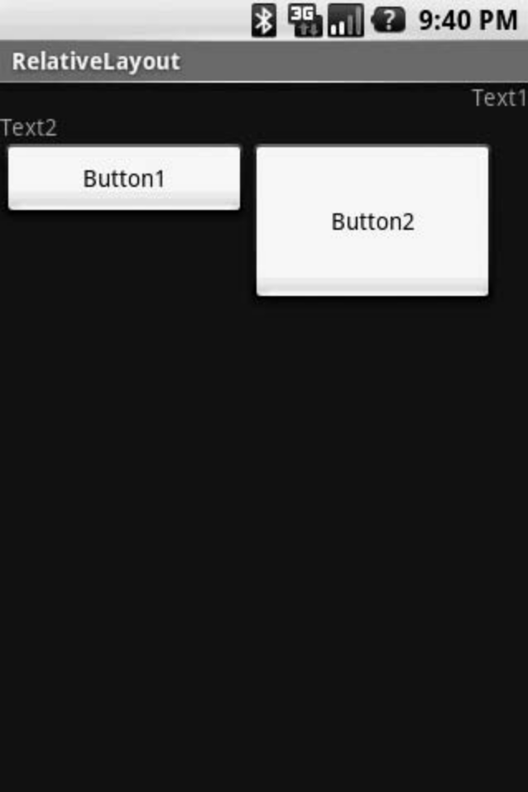
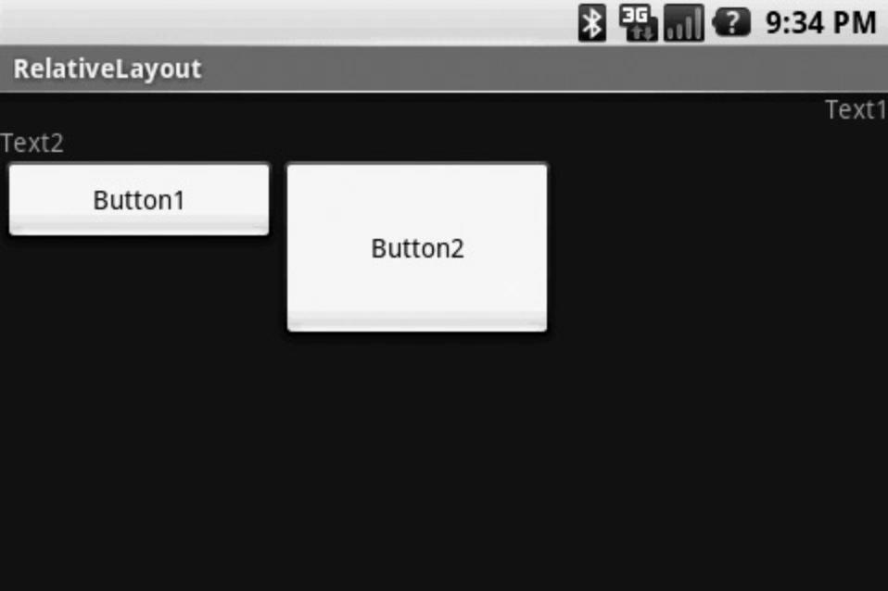

3-Drawing and Working with Animation
Working with Animation -One great way to add zing to your splash screen would be to add some animation. The Android platform supports four types of graphics animation:
Animated GIF images—Animated GIFs are self-contained graphics files with multiple frames.

Frame-by-frame animation—The Android SDK provides a similar mechanism for frame-by-frame animation in which the developer supplies the individual graphic frames and transitions between them (see the Animation Drawable class).

Tweened animation—Tweened animation is a simple and flexible method of defining specific animation operations that can then be applied to any view or layout.

OpenGL ES—Android’s OpenGL ES API provides advanced three-dimensional drawing, animation, lighting, and texturing capabilities.
For your application, the tweened animation makes the most sense. Android provides tweening support for alpha rotation, (transparency), scaling, and translating (moving) animations. You can create sets of animation operations do be done
simultaneously, in a timed sequence, and after a delay. Thus, tweened animation is a perfect choice for your splash screen.

With tweened animation, you create an animation sequence, either programmatically or by creating animation resources in the /res/anim directory. Each animation sequence needs its own XML file, but the animation may be applied to any number of View controls.
You can use the built-in animations provided in the android.R.anim class.
Adding Animation Resources
For your splash screen, you need to create three custom animations in XML and save them to the /res/anim resource directory: fade_in.xml, fade_in2.xml, and custom_anim.xml.

The first animation, fade_in.xml, simply fades its target from an alpha value of 0 (transparent) to an alpha value of 1 (opaque) over the course of 2500 milliseconds, or 2.5 seconds. There is no built-in animation editor in Eclipse. The XML for the fade_in.xml animation looks like this:

<?xml version=”1.0” encoding=”utf-8” ?>
<set
xmlns:android=”http://schemas.android.com/apk/res/android”
android:shareInterpolator=”false”>
<alpha
android:fromAlpha=”0.0”
android:toAlpha=”1.0”
android:duration=”2500”>
</alpha>
</set>
You can apply this animation to the top TextView control with your title text.

Next, you create the fade_in2.xml animation. This animation does exactly the same thing as the fade_in animation, except that you set the startOffset attribute to 2500 milliseconds. This means that this animation will actually take 5 seconds total: It waits 2.5 seconds and then fades in for 2.5 seconds. Because 5 seconds
is long enough to display the splash screen, you should plan to listen for fade_in2 to complete and then transition to the main menu screen.

Finally, you need some fun animation sequence for the TableLayout graphics. Inthis case, your animation set contains multiple, simultaneous operations: a rotation, some scaling, and an alpha transition. As a result, the target View spins into existence. The custom_anim.xml file looks like this:

<?xml version=”1.0” encoding=”utf-8” ?>
<set
xmlns:android=”http://schemas.android.com/apk/res/android”
android:shareInterpolator=”false”>
<rotate
android:fromDegrees=”0”
android:toDegrees=”360”
android:pivotX=”50%”
android:pivotY=”50%”
android:duration=”2000” />
<alpha
android:fromAlpha=”0.0”
android:toAlpha=”1.0”
android:duration=”2000”>
</alpha>
<scale
android:pivotX=”50%”
android:pivotY=”50%”
android:fromXScale=”.1”
android:fromYScale=”.1”
android:toXScale=”1.0”
android:toYScale=”1.0”
android:duration=”2000” />
</set>

As you can see, the rotation operation takes 2 seconds to rotate from 0 to 360 degrees, pivoting around the center of the view. The alpha operation should look familiar; it simply fades in over the same 2-second period. Finally, the scale operation scales from 10% to 100% over the same 2-second period. This entire animation takes 2 seconds to complete.After you have saved all three of your animation files, you can begin to apply the
animations to specific views.

Animating Specific Views
Animations must be applied and managed programmatically. Remember, costly operations, such as animations, should be stopped if the application is paused for some reason. The animation can resume when the application comes back into the
foreground.

Let’s start with a simplest case: applying the fade_in animation to your title TextView control, called TextViewTopTitle. All you need to do is retrieve an instance of your TextView control in the onCreate() method of the QuizSplashActivity class, load the animation resource into an Animation object, and call the startAnimation() method of the TextView control:

TextView logo1 = (TextView) findViewById(R.id.TextViewTopTitle);
Animation fade1 = AnimationUtils.loadAnimation(this, R.anim.fade_in);
logo1.startAnimation(fade1);

When an animation must be stopped—for instance, in the onPause() method of the
activity—you simply call the clearAnimation() method. For instance, the following
onPause() method demonstrates this for the corner logos:
@Override
protected void onPause() {
super.onPause();
// Stop the animation
TextView logo1 = (TextView) findViewById(R.id.TextViewTopTitle);
logo1.clearAnimation();
TextView logo2 = (TextView) findViewById(R.id.TextViewBottomTitle);
logo2.clearAnimation();
}
Animating All Views in a Layout
In addition to applying animations to individual View controls, you can also apply them to each child View control within a Layout (such as TableLayout and each TableRow), using LayoutAnimationController.

To animate View controls in this fashion, you must load the animation, create LayoutAnimationController, configure it as necessary, and then call the layout’s setLayoutAnimation() method. For example, the following code loads the custom_
anim animation, creates a LayoutAnimationController, and then applies it to each TableRow in the TableLayout control:

Animation spinin = AnimationUtils.loadAnimation(this, R.anim.custom_anim);
LayoutAnimationController controller =
new LayoutAnimationController(spinin);
TableLayout table = (TableLayout) findViewById(R.id.TableLayout01);
for (int i = 0; i < table.getChildCount(); i++) {
TableRow row = (TableRow) table.getChildAt(i);
row.setLayoutAnimation(controller);
}
There is no need to call any startAnimation() method in this case because LayoutAnimationController handles that for you. Using this method, the animation is applied to each child view, but each starts at a different time. (The default is 50% of the duration of the animation—which, in this case, would be 1 second.) This
gives you the nice effect of each ImageView spinning into existence in a cascading fashion.

Stopping LayoutAnimationController animations is no different from stopping individual animations: You simply use the clearAnimation() method. The additional lines to do this in the existing onPause() method are shown here:

TableLayout table = (TableLayout) findViewById(R.id.TableLayout01);
for (int i = 0; i < table.getChildCount(); i++) {
TableRow row = (TableRow) table.getChildAt(i);
row.clearAnimation();
}

Handling Animation Life Cycle Events
Now that you are happy with your animations, you just need to make QuizSplashActivity transition to QuizMenuActivity when the animations are complete. To do this, you create a new Intent control to launch the QuizMenuActivity class and call the startActivity() method. You should also call the finish() method of QuizSplashActivity because you do not want to keep this activity on the stack (that is, you do not want the Back button to return to this screen).

Of your animations, the fade_in2 animation takes the longest, at 5 seconds total. This animation is therefore the one you want to trigger your transition upon. You do so by creating an AnimationListener object, which has callbacks for the animation
life cycle events: start, end, and repeat. In this case, only the onAnimationEnd() method has an interesting implementation. Here is the code to create the AnimationListener and implement the onAnimationEnd() callback:

Animation fade2 = AnimationUtils.loadAnimation(this, R.anim.fade_in2);
fade2.setAnimationListener(new AnimationListener() {
public void onAnimationEnd(Animation animation) {
startActivity(new Intent(QuizSplashActivity.this,
QuizMenuActivity.class));
QuizSplashActivity.this.finish();
}
});
Now if you run the Been There, Done That! application again, either on the emulator or on the handset, you see some nice animation on the splash screen. The user
then transitions smoothly to the main menu screen, which is the next screen on your to-do list.

Summary
Congratulations! You’ve now implemented the first screen of the Been There, Done That! trivia quiz. In this hour, you designed a screen and then identified the appropriate
layout and View components needed to implement your design. After you included the appropriate resources, you were able to configure the splash.xml layout file. Finally, you added some tweened animations to the screen and then handled
the transition between QuizSplashActivity and QuizMenuActivity.

